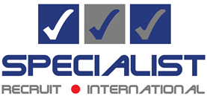

Specialist Recruit – Coronavirus update
The cure
Specialist Recruit has set up office remotely and have a range of online tools to enable us to continue to support our clients during this tricky time. We understand that recruitment is not high on most agendas, however if you do need to continue recruiting, we can help make the process run smoothly.
Hiring the right talent is critical for the growth of all businesses, maybe even more so in these circumstances. This is why we are all set up to help clients and candidates to transition from face-to-face meetings to remote video interviewing.
We've also enabled staff to work from home to ensure we continue the high levels of service and attention our clients would expect from us.
We are following local government advice and taking every precaution to ensure that the health and safety of our clients, candidates and our own people are paramount. Our consultants remain available through email, landline, mobile and video to assist you with finding a new role or hiring talent for your team. For more information, please call us on 01306 779250.
Yours sincerely,
Abbi Lampard
Director

